ANALYSIS REPORT

Question 1

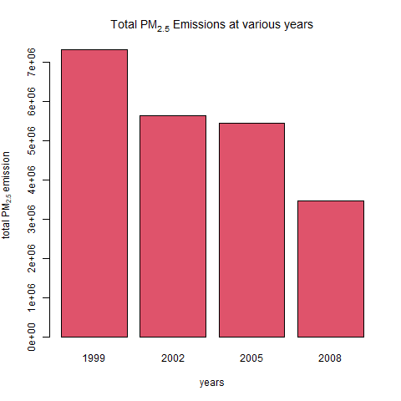

It is evident that there has been a continuous decline in the PM 2.5 emissions in the State with the most drops occurring between 1999 and 2002 as well as between 2005 and 2008, naturally resulting in the lowest emissions in 2008

Question 2

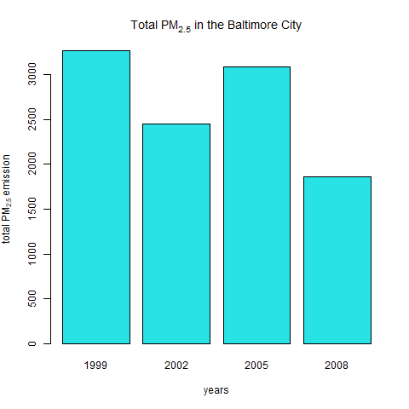

Constant fluctuation is observed when considering the graph above however a general decrease is observed as the maxima is reduced with each fluctuation, with the latest reading be the least emissions observed. Should the pattern continue an increase averaging at a reading of 1500 at Baltimore followed by a decrease can be expected.

Question 3

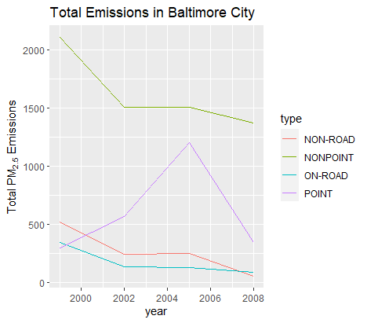

Combining the observations of the graph above and of #2 we see that point locations accounted for the increase in Baltimore’s emissions with a decline after the peak in 2005. All other sources where in constant decline with no changes being observed between 2002 and 2005. All source types displayed a decline in 20008

Question 4

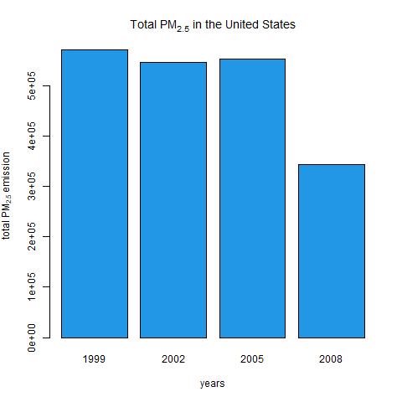

Throughout the assessment period, emissions where above 500 000 units with a slight decrease in 2002 and a significant decline in to 343432.2 units in 2008. Crucial observations with coal sources is that between 2002 and 2005 there was a slight decrease in the sources but an increase in emissions. This may be attributed to higher demand. The sources in 1999 and 2008 have a difference of 9 facilities but the emissions display a very large decrease in emissions. The real change in processes may be observed in 2002 as opposed to 2008 in the sense that a great number of facilities were introduces but emissions decreased.

|  |  |  |  |
| --- | --- | --- | --- |
| Coal utilisation sources | | | |
| 1999 | 2002 | 2005 | 2008 |
| 5570 | 8683 | 8646 | 5581 |
| 572 126.5 | 546 789.2 | 552 881.5 | 343 432.2 |

Question 5

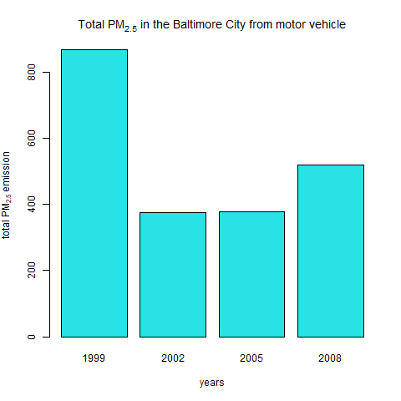

1999 saw the highest PM2.5 emissions throughout the observation period. In 2002 the emissions more than halved in the year 2002 and remained at the 2002 levels in 2005. An increase in the PM2.5 records were recorded in 2008. Though no official investigations were conducted, the increase may be attributed in the upturn in economic activity and movement following the financial fallout in the previous year.

Question 6

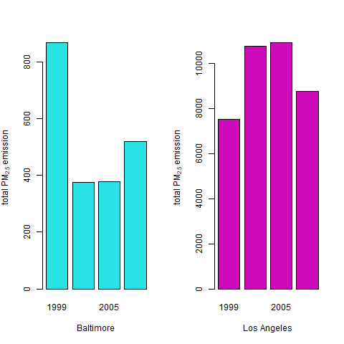

The readings from Los Angeles challenge the proposition that economic rebound to be the cause of the increase in emissions. However, there are a number of points that separate the two locations first being the difference in the shape of the graph with LA displaying a concave shape, i.e. the highest readings in the middle years of the observation period followed be a decline in the last year whilst Baltimore displays the exact opposite. Overall LA displayed higher emissions over the 2002 to 2008 period. Thus, although emissions in LA declined in 2008 they were still higher than that of Baltimore. Furthermore, considering the beginning and the end of the survey period LA’s PM 2.5 emissions have increased raising concerns over the execution of set policies and global compact commitments.

Possible cause for Higher emissions in Los Angeles

|  |  |  |
| --- | --- | --- |
| year | Baltimore | Los Angeles |
| 1999 | 282 | 178 |
| 2002 | 432 | 531 |
| 2005 | 435 | 527 |
| 2008 | 415 | 1083 |

The data shows a significantly small number mobile sources in Los Angeles compared to Baltimore in 1999. This changed in 2002 where the source almost quadrupled in 2002 and exceeding Baltimore and explaining part of the higher rate.

For the rest of the period LA had a larger number of sources. What is interesting is that in 2005 although the number of sources in LA decreased, emissions increased, of even more interest is that in 2008 the sources more than doubles emissions where significantly reduced

Conclusion

The preliminary analysis depicts varying insight and calls for further investigation both forward and backward analysis. Forward in modelling different interactions between variables as well as for different years. Backward in obtaining missing values and validating the values.

However, there has been a marked decrease in emissions wholistically.